NYC One-Bed Rents — Mean, Median, Mode
HousingCT_Py · Codecademy Stats with Python extension · StreetEasy Brooklyn / Manhattan / Queens
Problem Statement:
A renter, an analyst, and a housing executive all ask the same loose question — “what does a one-bedroom cost in Brooklyn, Manhattan, and Queens?” — but they need different numbers. The mean is pulled up by luxury listings; the median is the typical ask; the mode is the most common listed price. Using three StreetEasy extracts (Brooklyn n=1,013, Manhattan n=1,476, Queens n=232) we compute all three measures, show the right-skew on histograms, and flag a data trap: despite its filename, brooklyn-one-bed.csv is a mixed-bedroom file (studios through 5-beds), while the Manhattan and Queens files are already 1-bed only. The brief is to report the lesson numbers on the raw rent column, then show how a fair 1-bed filter changes Brooklyn.
Solution Strategy:
1) Load the three CSVs and extract rent. 2) Inspect n, min/max, and bedrooms.value_counts before trusting the filename. 3) Mean = sum/n (np.mean); median = middle of the sorted vector (np.median); mode = most frequent ask (scipy.stats.mode and value_counts). 4) Rank boroughs on each measure and test the rule of thumb mode ≤ median ≤ mean. 5) Overlay the three statistics on histograms (clip the 99th percentile so the luxury tail does not squash the mass). 6) Recompute Brooklyn on bedrooms==1. 7) Monte-Carlo: bootstrap the width of the mean vs n, then inject $25k outliers to watch the mean move and the median stay put. 8) Rewrite one headline for analyst / technician / executive / nonspecialist audiences. Advertised asks ≠ signed leases.
Solution:
Borough | n | Mean | Median | Mode (count) | Mean − median
Queens | 232 | $2,346 | $2,200 | $1,750 (11) | +$146
Brooklyn (raw file) | 1,013 | $3,327 | $3,000 | $2,500 (26) | +$327
Manhattan | 1,476 | $3,993 | $3,800 | $3,500 (56) | +$193
Brooklyn, 1-bed only | 340 | $2,785 | $2,800 | $2,200 (12)* | −$15
*Brooklyn 1-bed is bimodal at $2,200 and $2,500 (12 listings each); value_counts.idxmax returns $2,200. Filtering true 1-beds drops the Brooklyn mean by ~$542 and widens the gap versus Manhattan. Ranking on the raw file is Manhattan > Brooklyn > Queens on every measure; all three raw series are right-skewed.
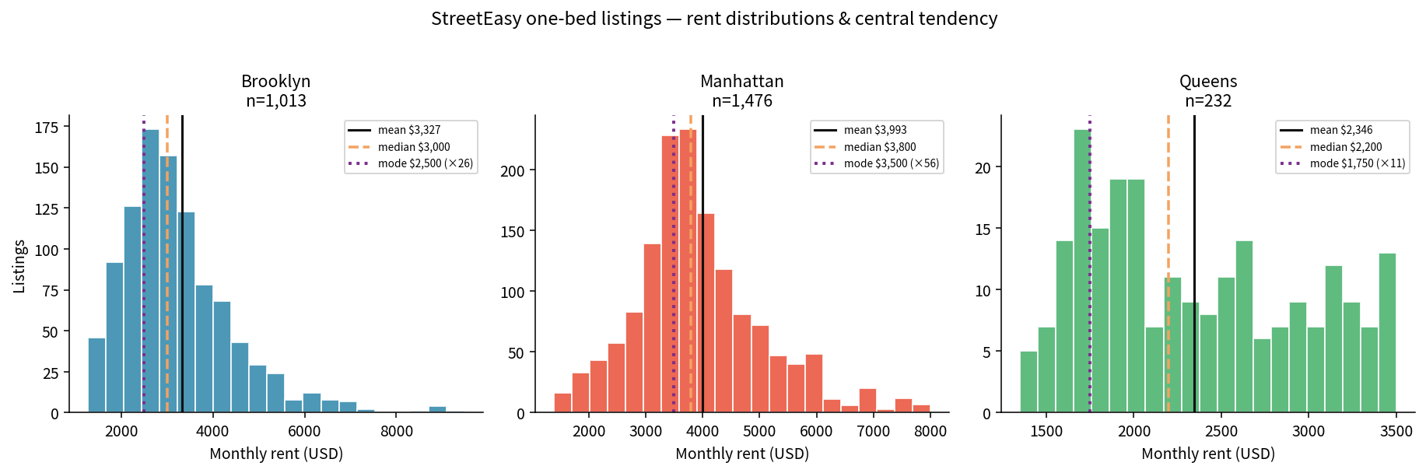
Figure 1. Rent histograms with mean (solid), median (dashed), mode (dotted). X-axis clipped at the 99th percentile.
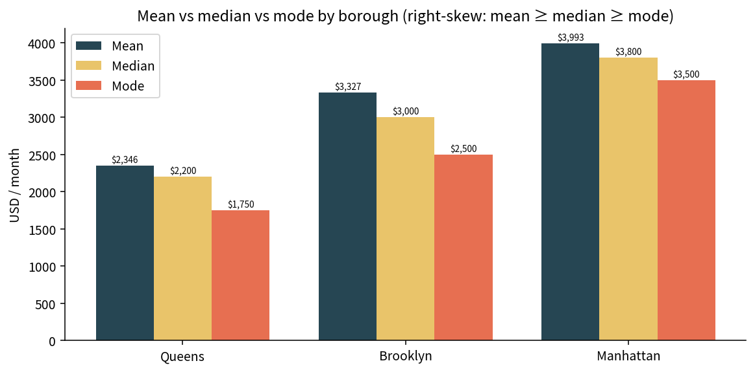
Figure 2. Mean vs median vs mode by borough.
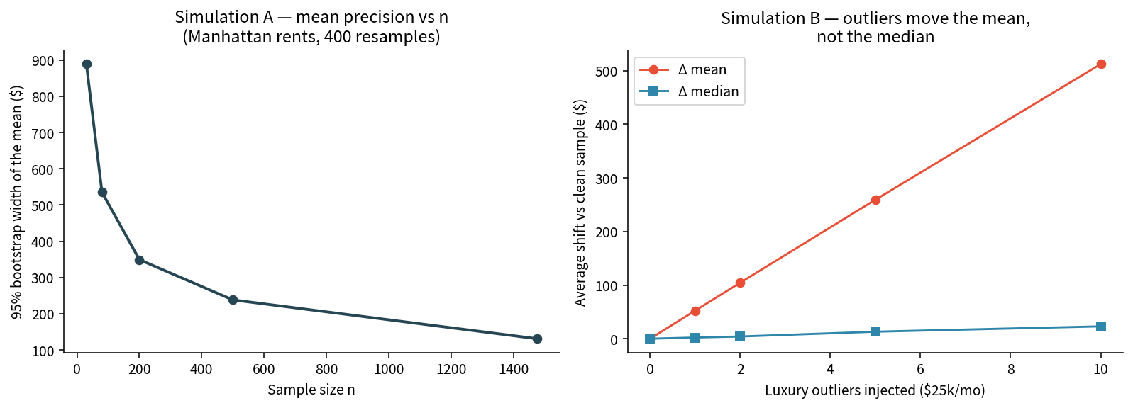
Figure 3. Left: bootstrap width of the Manhattan mean shrinks with n. Right: $25k outliers shift the mean, not the median.
Key Takeaways:
- Use the median for “typical listed rent.” Use the mean only when you are adding rents (a portfolio). Use the mode for the most common asking price.
- Right-skew is the default shape of advertised urban rents: a short stack of luxury listings lifts the average above what most renters will see.
- Filenames lie. Brooklyn’s so-called one-bed file is mixed-bedroom; always tabulate bedrooms before you brief a client.
- Queens n=232 is a small snapshot — its mode ($1,750, 11 listings) is a soft signal. Manhattan n=1,476 is the stablest of the three.
- Sample size buys precision on the mean; it does not protect the mean from a $25k outlier. The median is the robust headline.
- Listed ≠ leased. StreetEasy coverage misses rent-stabilized stock and informal sublets. This is a teaching extract, not a valuation and not rental advice.

